Install LEPP(Linux, Nginx, PostgreSQL, PHP) on CentOS 7.4

Pertama tambah repository PostgreSQL
jika belum memiliki repository postgre bisa lakukkan perintah di bawah ini
# wget http://yum.postgresql.org/9.4/redhat/rhel-7Server-x86_64/pgdg-centos94-9.4-1.noarch.rpm

lalu install repository yang telah kita download
# yum install pgdg-centos94-9.4-1.noarch.rpm

terakhir install postgreSQL
# yum install postgresql94-server postgresql94-contrib

lalu setup database
# /usr/pgsql-9.4/bin/postgresql94-setup initdb

ketika installasi sudah selesai, lalu kita restart postgresnya
# systemctl restart postgresql-service

dan enable
# systemctl enable postgresql-service

lalu cek apakah postgre kita sudah berjalan atau belu
# systemctl status postgresql-service

kedua install nginx
sama seperti menginstall postgres kita harus mendownload repository nginx terlebih dahulu, lalu install repo dan install nginx
# wget http://nginx.org/packages/centos/7/noarch/RPMS/nginx-release-centos-7-0.el7.ngx.noarch.rpm
# yum install nginx-release-centos-7-0.el7.ngx.noarch.rpm
# yum install nginx

setelah kita menginstall nginx kita lakukan konfigurasi
edit konvigurasi server
vi /etc/nginx/nginx.conf

lalu buka
vi /etc/nginx/nginx.conf.default
server {
listen 80;
server_name localhost;

#charset koi8-r;

#access_log logs/host.access.log main;

location / {
root /usr/share/nginx/html;
index index.php index.html index.htm;
}

#error_page 404 /404.html;
Make the following edits:
- Set server_name from localhost to your_web_server_ip.
- Add index.php to the index directive so it reads index.php index.html index.htm.
- Delete the location / { and } lines containing the root and index directives. Without this change you may find your web page not displaying in the browser and the Nginx error log recording messages like "Unable to open primary script: /etc/nginx/html/index.php (No such file or directory)"
- Uncomment the location ~ \.php$ block (including the last curly bracket) under the pass the PHP scripts to FastCGI server comment.
- Delete the root directive under the same location ~ \.php$ block.
- Change fastcgi_pass directive value from 127.0.0.1:9000 to unix:/var/run/php-fpm/php5-fpm.sock. This is to ensure the PHP FastCGI Process Manager (which we'll install in the next step) will be listening to the Unix socket.
- Change te fastcgi_param directive value to SCRIPT_FILENAME $document_root$fastcgi_script_name. This tells the web server that PHP script files will be saved under the document root directory.
# pass the PHP scripts to FastCGI server listening on 127.0.0.1:9000
#
location ~ \.php$ {
fastcgi_pass unix:/var/run/php-fpm/php5-fpm.sock;
fastcgi_index index.php;
fastcgi_param SCRIPT_FILENAME $document_root$fastcgi_script_name;
include fastcgi_params;
}

lalu restart nginx
# systemctl restart nginx.service

lalu buka localhost, makan akan muncul gambar seperti di bawah ini
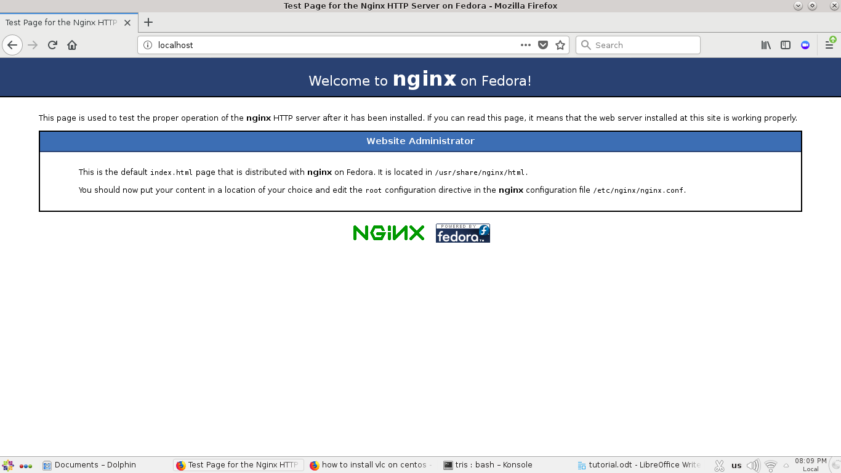

ketiga install php
# yum install php

Next we will install the FastCGI processes trainer (FPM), which is PHP's own implementation of FastCGI. FastCGI is like an add-on on top of your web server. It runs independently and helps speed up user questions by consolidating them in one individual processes, thus speeding up response moment.

# yum install php-fpm
Finally, install the PHP Postgres module:
# yum instapp php-pgsql

langkah terakhir configurasi php
# vi /etc/php.ini

Make the following actions:
- Change expose_php = On to expose_php = Off. Setting this parameter to Off just means PHP doesn't add its signature to the web server's header and doesn't expose the fact that the server is running PHP.
- Change ;cgi.fix_pathinfo=1 to cgi.fix_pathinfo=0

lalu edit konfigurasi FPM nya
# vi /etc/php-fpm.d/www.conf
Make the following actions:
- Change user = apache to user = nginx.
- Similarly, change group = apache to group = nginx.
- Change listen = 127.0.0.1:9000 to listen = /var/run/php-fpm/php5-fpm.sock. We set this same value in the Nginx default server block's configuration file.

Ngalakan php-fpm nya
# systemctl start php-fpm.service
lalu enable
# systemctl enable php-fpm.service

buat dile info.php pada folder /usr/share/nginx/html
vi /usr/share/nginx/html/info.php

isi dengan
<?php
phpinfo();
?>

lalu buka web browser dan jalankan
localhost/info.php
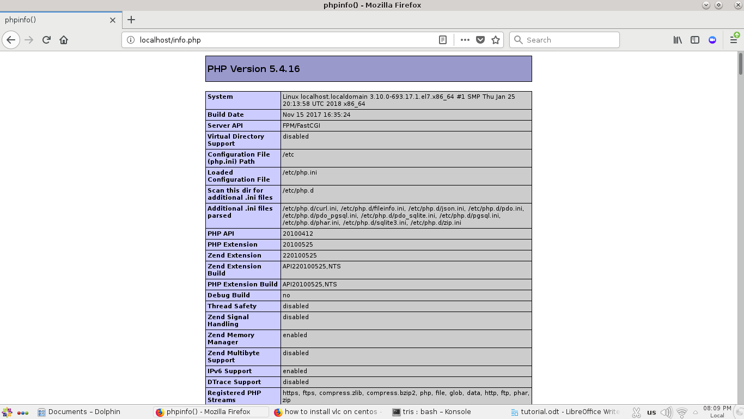
https://www.youtube.com/watch?v=ACxbqI1PU2A
https://fxdata.cloud/tutorials/set-up-a-two-node-lepp-stack-on-centos-7

